**AWS 101 EC2 : Elastic Compute Cloud**

*Posted On September 5, 2019*

Amazon Elastic Compute Cloud (Amazon EC2) is a web service that provides scalable compute capacity in the cloud. It reduces the time required to obtain and boot new server instances within fraction of time (minutes), allowing you to quickly scale capacity, both up and down, as per computing requirements.

**EC2 Pricing Models**

On Demand: Allows you to pay a fixed rate by the hour with no commitment.

Reserved: Provides you with a capacity reservation, and offer a significant discount on the hourly charge for an instance. Contract terms are 1 year or 3 years term.

Spot: Enables you to bid for instance capacity at whatever price you want, providing for even greater savings if your applications have flexible start and end times.

Dedicated Hosts: Physical EC2 server dedicated for your use. Dedicated Hosts can help you reduce costs by allowing you to use your existing server-bound software licence.

The Amazon EC2 instance will provide a wide range of selection in the instance types which are specifically optimized to fit the various use cases. Each Amazon EC2 instance type will typically contain one or more instance sizes by allowing the resources to the targeted workload.

AWS categorizes EC2 instance types generally into 5 types. They are

* General Purpose – (T2, M5, M4, M3)
* Memory Optimized – (X1, R4, R3)
* Computer Optimized – (C5, C4, C3)
* Accelerated Computing – (P3, P2, G3, F1)
* Storage Optimzed – (I3)

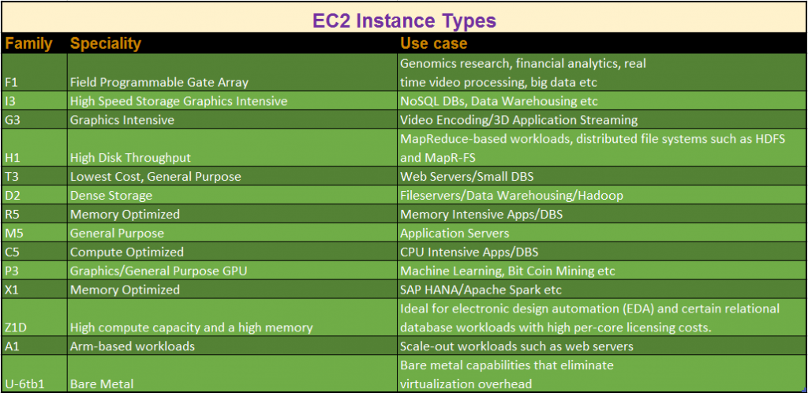  
For more information on Instance Types, refer link :- <https://docs.aws.amazon.com/AWSEC2/latest/UserGuide/instance-types.html>